Alvin Little League supplies some equipment for players, while other equipment must be supplied by the player. See below for a list of items recommended and required.
Supplied By Player
- Baseball Glove (appropriately sized)
- Backpack or equipment bag
- Rubber-soled cleats
- Personal batting helmet
- Batting gloves (optional)
- Bat (Must meet USA Bat standard. Visit https://www.littleleague.org/playing-rules/bat-information/ for more information). Coach pitch and up cannot use T-ball bat
- Baseball pants for practice (optional)
Supplied by Alvin Little League
- Jersey
- Hat
- Belt
- Socks
- Catchers Gear
- Baseballs for practices and games

Youth Baseball Glove Size Chart Recommendation
Position | Up to 5 Years Old | 6-7 Years Old | 8-10 Years Old | 11-12 Years Old
Infielder | 10.5" | 8" - 10.5" | 10" - 11.5" | 11" - 12"
Outfielder | 10.5" | 9" - 10.5" | 10" - 11.5" | 11" - 12"
Pitcher | 10.5" | 8" - 10.5" | 10.5" - 11" | 11" - 12"
Catcher* | 10.5" | 29.5" - 30" | 30" - 32" | 30" - 32.5"
First Base | 10.5” | 11.5” | 11.5" - 12" | 11.5" - 12"
*You measure catcher’s mitts and baseball gloves with different standards/techniques.

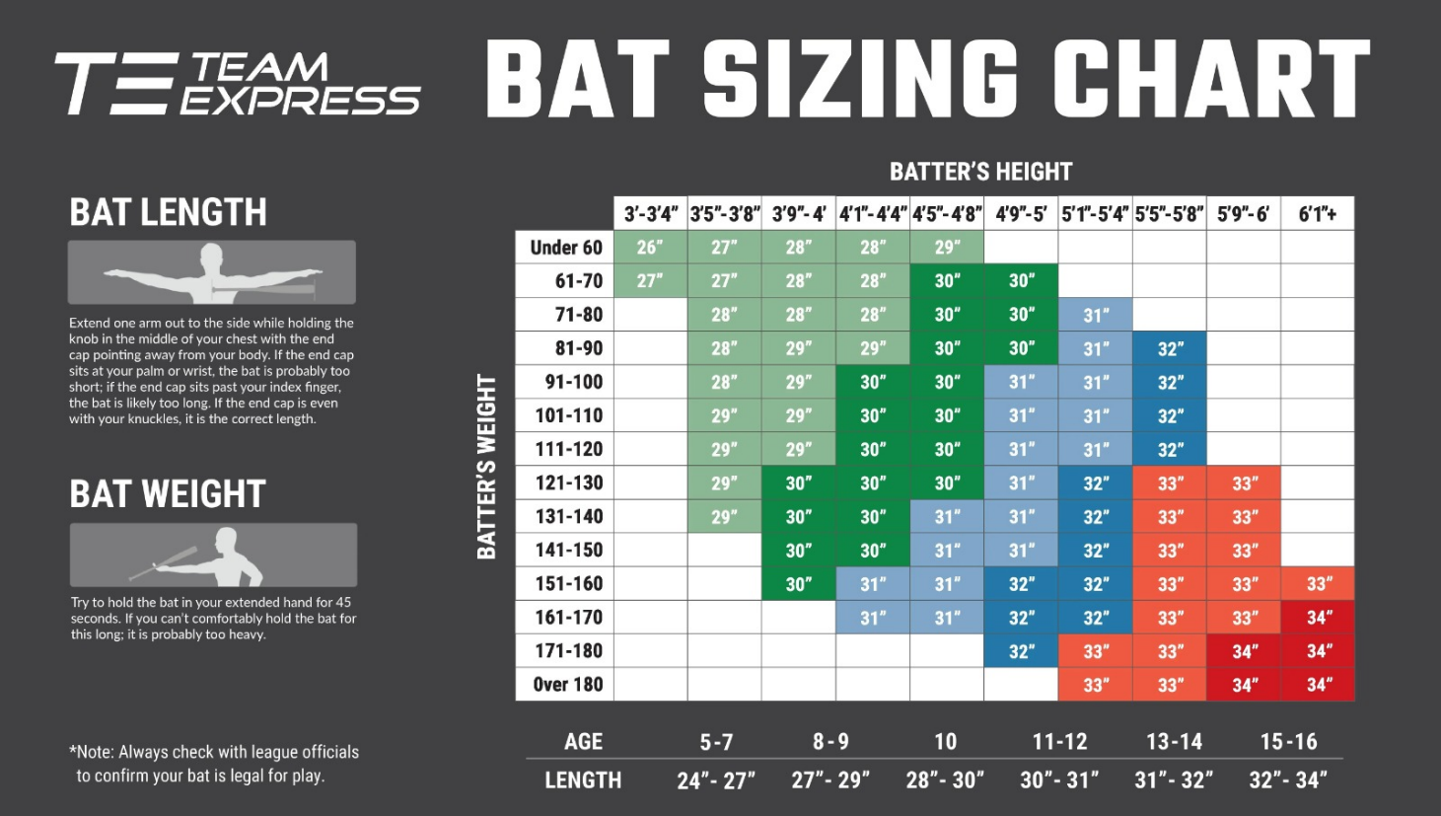
Little League Bat Weight/Drop Chart (Ages 8-10)
Player Height | Bat Weight | Bat Length | Bat Drop
4’ - 4’2” | 16-17 ounces | 28 inches | -11 or -12
4’3” - 4’6” | 17-18 ounces | 28 inches | -10 or -11
4’7” - 4’9” | 18-19 ounces | 29 inches | -10 or -11
5’ or taller | 19-20 ounces | 30 inches | -10 or -11
The measurements, weights, and drops are only general recommendations.

T Ball Bat Size Chart
Age | Avg. Player Height | Avg. Player Weight | Tee Ball Bat Length | Tee Ball Bat Drop | Tee Ball Bat Weight
4 | 40.3 in. | 36 lbs. | 24 in. | -11 to -13 | 11-13 oz.
5 | 43 in. | 40.5 lbs. | 25 in. | -11 to -12 | 13-14 oz.
6 | 45.5 in. | 45.5 lbs. | 25 in. | -10 to -11 | 14-15 oz.
7 | 48 in. | 50.5 lbs. | 26 in. | -10 to -11 | 15-16 oz.
This chart only shows averages or estimations of measurements, ages, & weights. Measure your child for the most accurate bat size & weight.

